**VARUN KUMAR**

**2K19-IT-140**

**OOP LAB - 4**

**#include <iostream>**

**using namespace std;**

**class student_DTU{**

**string name;**

**int roll,marks,Package_offered,Age;**

**char P_grade,grade;**

**int College_id;**

**public:**

**void Package_grade(){**

**if(Package_offered>15) P_grade='A';**

**else P_grade='B';**

**}**

**void Name_ascii(){**

**cout<<(int)name[0];**

**}**

**void Marks_grade(){**

**if(marks>80) grade='A';**

**else if(marks>60) grade='B';**

**else grade='C';**

**}**

**student_DTU(){**

**roll=0; marks=0;**

**Package_offered=0;**

**Age=0;**

**cout<<"Welcome - ";**

**}**

**void get_data(){**

**cout<<"Enter name , roll , marks , Package_offered , Age , College_id:- "<<endl;**

**cin>>name>>roll>>marks>>Package_offered>>Age>>College_id;**

**}**

**int Package_offered_get(){**

**return Package_offered;**

**}**

**int Age_get(){**

**return Age;**

**}**

**} S ; //global object**

**class college{**

**string name;**

**int College_id;**

**string State;**

**int Sem_fees_btech;**

**int Percentage_stud_placement;**

**public:**

**void Remarks_for_college_print(){**

**if(Percentage_stud_placement>80) cout<<"Good";**

**else cout<<"not good";**

**}**

**college(){**

**College_id=0; Sem_fees_btech=0;**

**Percentage_stud_placement=0;**

**}**

**void get_data(){**

**cout<<"Enter name , College_id , State , Sem_fees_btech , Percentage_stud_placement:- "<<endl;**

**cin>>name>>College_id>>State>>Sem_fees_btech>>Percentage_stud_placement;**

**}**

**int Sem_fees_btech_get(){**

**return Sem_fees_btech;**

**}**

**} C; // global declare**

**int calculate_Tax(){**

**int tax=abs(((S.Package_offered_get())/S.Age_get()) - (C.Sem_fees_btech_get()*8));**

**return tax;**

**}**

**int main(){**

**S.get_data();**

**C.get_data();**

**cout<<"Tax calculated: "<<calculate_Tax();**

**return 0;**

**}**

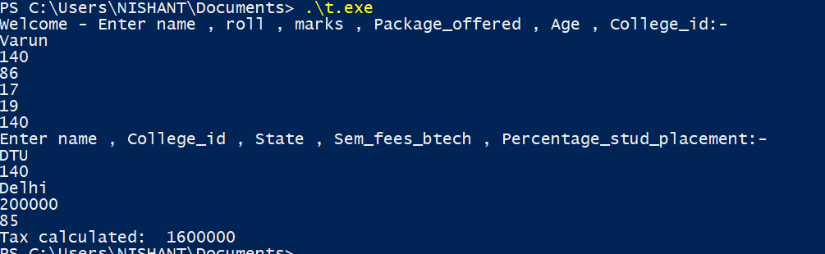

**2.**

**#include <iostream>**

**using namespace std;**

**class car{**

**int model_no;**

**string name;**

**int price;**

**float insurance_expected;**

**public:**

**float cal_insurance(){**

**insurance_expected=(float)price*0.010;**

**return insurance_expected;**

**}**

**void get_data(){**

**cout<<"enter model_no , name and price :- "<<endl;**

**cin>>model_no>>name>>price;**

**}**

**void print(){**

**cout<<endl;**

**cout<<"model_no: "<<model_no<<endl;**

**cout<<"name: "<<name<<endl;**

**cout<<"price: "<<price<<endl;**

**cout<<"insurance_expected: "<<insurance_expected<<endl;**

**}**

**car(){**

**model_no=0; price=0;**

**insurance_expected=0;**

**}**

**} C ; //global object**

**class insurance_policy{**

**int policy_no;**

**string name_of_policy;**

**int amount;**

**float discount;**

**public:**

**float cal_discount(){**

**discount=(float)amount*0.10;**

**return discount;**

**}**

**void get_data(){**

**cout<<"enter policy_no , name_of_policy , amount : - "<<endl;**

**cin>>policy_no>>name_of_policy>>amount;**

**}**

**void print(){**

**cout<<endl;**

**cout<<"policy_no: "<<policy_no<<endl;**

**cout<<"name_of_policy: "<<name_of_policy<<endl;**

**cout<<"amount: "<<amount<<endl;**

**cout<<"discount: "<<discount<<endl;**

**}**

**insurance_policy(){**

**policy_no=0;**

**amount=0;**

**discount=0;**

**}**

**} P ; //global object**

**class service_station{**

**string name,location;**

**float average_bill;**

**float discount;**

**public:**

**float cal_discount(){**

**discount=average_bill*0.10;**

**return discount;**

**}**

**void get_data(){**

**cout<<"enter name , location , average_bill:- "<<endl;**

**cin>>name>>location>>average_bill;**

**}**

**void print(){**

**cout<<endl;**

**cout<<"name: "<<name<<endl;**

**cout<<"location: "<<location<<endl;**

**cout<<"average_bill: "<<average_bill<<endl;**

**cout<<"discount: "<<discount<<endl;**

**}**

**} S ; //global object**

**class person_data{**

**float my_car_insurance;**

**float my_insur_discount;**

**float my_service_station_amount;**

**float total_expenditure;**

**public:**

**void car_total_Expenditure(){**

**total_expenditure=my_car_insurance + my_insur_discount + my_service_station_amount;**

**}**

**void set_data(){**

**my_car_insurance=C.cal_insurance();**

**my_insur_discount=P.cal_discount();**

**my_service_station_amount=S.cal_discount();**

**}**

**void print(){**

**cout<<endl;**

**cout<<"my_car_insurance: "<<my_car_insurance<<endl;**

**cout<<"my_insur_discount: "<<my_insur_discount<<endl;**

**cout<<"my_service_station_amount: "<<my_service_station_amount<<endl;**

**cout<<"total_expenditure: "<<total_expenditure<<endl;**

**}**

**} PD ; //global object**

**int main(){**

**C.get_data();**

**P.get_data();**

**S.get_data();**

**C.cal_insurance();**

**P.cal_discount();**

**S.cal_discount();**

**PD.set_data();**

**PD.car_total_Expenditure();**

**C.print();**

**P.print();**

**S.print();**

**PD.print();**

**return 0;**

**}**

